abstract modifier

1. abstract is the modifier applicable for classes, methods but not for variables.

abstract method

* 1. Even though we don’t know about implementation still we can declare a method with abstract modifier that’s for abstract method, only declaration is available but not implementation. Hence abstract method declaration should end with semicolon.
  2. **Example**:   
     public abstract void getNoOfWheels();
  3. Child class is responsible to provide implementation for parent class abstract method.
  4. 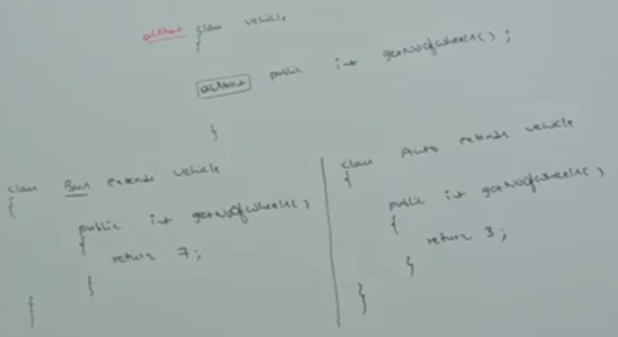
  5. By Declaring abstract method in the parent class, we can provide to the child class such as which method is compulsory and child class has to implement.
  6. abstract method never talks about implementation. If any modifier talks about implementation then it forms illegal combination with abstract modifier.   
     The following are illegal combinations of modifiers for methods wrt abstract modifier:  
     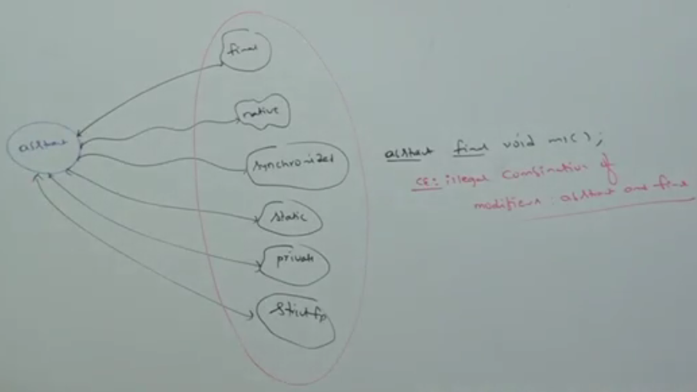

abstract class

1. **Definition**: For any java class, if we are not allowed to create an object (because of partial implementation) such type of class we have to declare with **abstract modifier.** That is for abstract classes, instantiation is not possible.
2. **Example**:   
   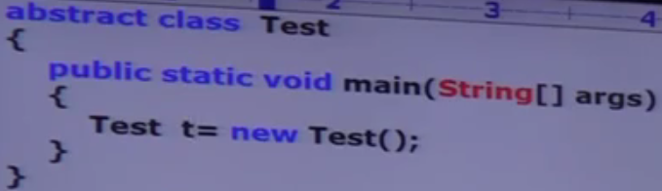
3. **d**

abstract class vs. abstract method

1. If a class contains at least one abstract method, then It is necessary we should declare the class as abstract otherwise we will get compile time error.  
   If a class contains at least one abstract method then implementation is not complete and hence it’s not recommended to create its object. To restrict object instantiation, compulsory we should declare class as abstract.
2. Even though, class doesn’t contain any abstract method, still we can declare class as abstract. If we don’t want instantiation, that is abstract can contain 0 number of abstract method.  
   **Example**: HttpServlet 🡨 abstract class with no abstract method  
   **Example**: **Adapter Classes** 🡨 Recommended to be declared as abstract even though these classes don’t have any abstract method.
3. Some Points:
   1. 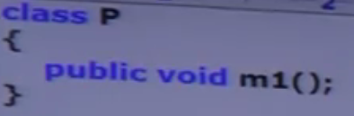  
      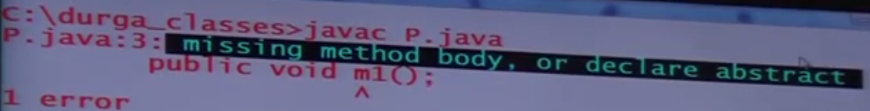
   2. 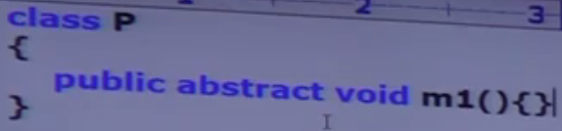  
      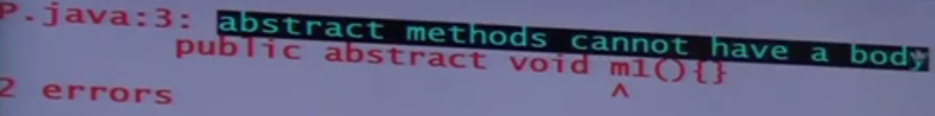
   3. 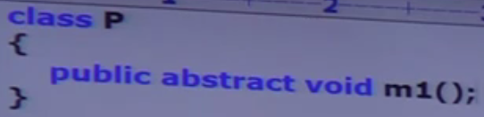



1. If we are extending an abstract class, for each and every abstract method in parent class must be implemented in child class otherwise declare the child class as abstract class.   
   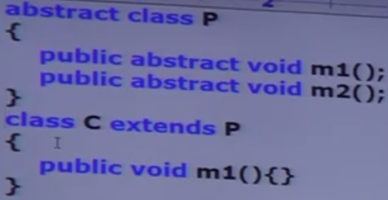

this class doesn’t override m2() abstract method from parent.

1. d

final vs. abstract

1. abstract method must be overridden in child classes to provide implementation whereas we can’t override final method hence final abstract combination for a method is illegal combination.
2. For final classes, we can’t create child classes whereas for abstract classes we should create child to provide implementation. Hence, final abstract combination for class level is illegal.
3. Inside abstract class, there may be final method whereas final class can’t have abstract method. ☺